Reducing LLM Subscription Dependency Through a
Deterministic Skill-Runner Reporting Architecture

Submitted by:
Trey Lumley
For the fulfillment of the degree requirements of
Master of Science in Information Technology
Supervised by:
Dr. Sirisha Pavuluri
Department of Computer Science
University of the People, Pasadena, CA,United States
Academic Year 2026, Term 5 - August 2026
https://github.com/treysl/skill-runner

ABSTRACT
This project develops and evaluates a deterministic skill-runner for automated business-intelligence reporting. The project addresses a practical dependency created when reusable reporting workflows remain inside subscription-based large language model chat sessions: outputs are difficult to reproduce, business logic is hard to audit, and service, pricing, rate-limit, or policy changes can interrupt reporting. The implemented prototype combines an n8n trigger layer, a locally hosted FastAPI service, workbook inspection, schema-bound configuration, deterministic defaults, an optional OpenRouter decision step, and a versioned Construction-in-Process reporting skill. Testing used an anonymized 6,989-row export. All 29 automated unit tests passed; unsafe path traversal was rejected; the generated 3.93 MB workbook opened with nine worksheets; and an instrumented end-to-end run completed in 87.314 seconds with a verified audit manifest and output hash. A same-input, same-filter Claude Teams reproduction required 19 model-reported execution steps and 5 minutes 59 seconds, followed by approximately one minute of comparative review. The skill-runner completed the comparable execution about 4.1 times faster, reduced elapsed execution time by 75.7 percent, and incurred approximately $0.02 in OpenRouter cost using DeepSeek V4 Flash, compared with the organization's $125-per-month Claude Teams 5x plan. These are single-run prototype observations rather than guaranteed service or pricing levels. The results show that probabilistic AI can be bounded to a replaceable configuration function while calculations, file controls, and report generation remain deterministic and testable. Production use still requires approved financial reconciliation, authentication, centralized operations, backup, and controlled deployment.

ACKNOWLEDGEMENTS
I would like to thank Dr. Sirisha Pavuluri for guidance and feedback throughout the project, the Department of Computer Science at the University of the People for the academic framework that shaped the project, and my colleagues and organizational leadership for supporting the reporting-pipeline experiment. I am also grateful to the analysts who provided practical context about current reporting workflows and helped keep the prototype focused on a real operational need. Their support made it possible to connect project-management concepts, software-engineering practices, and business-intelligence requirements in one working proof of concept.

TABLE OF CONTENTS
ABSTRACT 1
ACKNOWLEDGEMENTS 2
TABLE OF CONTENTS 3
LIST OF TABLES 6
LIST OF FIGURES 7
ABBREVIATIONS AND SYMBOLS 8
Chapter 1: Introduction 1
1.1 Background of the Study 1
1.2 Problem Statement 2
1.3 Objectives and Research Questions 4
1.4 Scope and Limitations 5
1.5 Ethical, Security, and Stakeholder Considerations 6
1.6 Report Organization 7
Chapter 2: Literature Review 8
2.1 LLM-Augmented ETL and Enterprise Intelligence 8
2.2 Reusable Skills, Agents, and Domain Logic 9
2.3 Reproducibility and Software Assurance 10
2.4 CI/CD and Traceable Change 11
2.5 System Testing and Maintenance 12
2.6 Research Gap and Project Position 13
Chapter 3: System Design and Methodology 14
3.1 System Architecture 14
3.2 Data Flow and Component Boundaries 17
3.3 Core Algorithms 18
3.3.1 Input Discovery and Filesystem Validation 18
3.3.2 Workbook Inspection and Pre-flight Metadata 18
3.3.3 Schema-Driven Orchestration 19
3.3.4 Deterministic Fallback and Build Execution 20
3.4 Tools and Configuration 21
3.5 Security and Ethical Design Controls 21
3.6 Evaluation Methodology 22
Chapter 4: Results and Evaluation 24
4.1 Implementation Outcome 24
4.2 Integrated System Output 25
4.3 System and Acceptance Test Results 27
4.4 Performance and Resource Results 30
4.4.1 Comparative Claude Execution Evidence 33
4.5 Defects, Corrections, and Remaining Issues 33
Chapter 5: Discussion 35
5.1 Interpretation of Results 35
5.2 Project Management and Deployment Implications 37
5.3 Limitations 38
5.4 Maintenance Strategy 40
5.5 Change, Release, and Recovery Control 41
Chapter 6: Conclusion and Future Work 43
6.1 Conclusion 43
6.2 Contributions 44
6.3 Lessons Learned 44
6.4 Future Work 45
REFERENCES 48
APPENDIX A: EVIDENCE INVENTORY 50
APPENDIX B: RELEASE CHECKLIST 51

LIST OF TABLES
Table 1. Project objectives and acceptance evidence 4
Table 2. Major system modules and responsibilities 16
Table 3. System test environment and evidence baseline 22
Table 4. Unit, integration, system, acceptance, and performance test summary 27
Table 5. Measured latency, throughput, memory, and batch runtime 31
Table 6. Resolved defects, environment issues, and coverage limitations 31
Table 7. Maintenance categories applied to the skill-runner 38
Table 8. Monitoring and maintenance schedule 38
Table 9. Priority maintenance risks and response controls 40
Table 10. Testing and evaluation evidence inventory 48

LIST OF FIGURES
Figure 1. System architecture showing n8n triggers, the local FastAPI runner, packaged skill assets, input/output directories, and optional OpenRouter orchestration. 14
Figure 2. Request sequence from the user and n8n through inspection, configuration, report construction, and the final success or error payload. 15
Figure 3. Successful n8n end-to-end workflow used to trigger and monitor the CIP report pipeline. 26
Figure 4. Fresh automated test execution showing 18 tests passed with no failures or errors. 28
Figure 5. Live API integration evidence for health, input discovery, and 6,989-row workbook inspection. 28
Figure 6. Acceptance evidence confirming API availability, invalid-request handling, and the workbook contract. 29

ABBREVIATIONS AND SYMBOLS
Abbreviation | Meaning
API | Application programming interface
BI | Business intelligence
CI/CD | Continuous integration and continuous delivery/deployment
CIP | Construction in Process
ETL | Extract, transform, and load
HTTP | Hypertext Transfer Protocol
JSON | JavaScript Object Notation
LLM | Large language model
RSS | Resident set size
SSRS | SQL Server Reporting Services
YTD | Year to date

Chapter 1: Introduction

1.1 Background of the Study
In my role as Director of Business Intelligence at a "CFO-as-a-service" consulting firm for large landscape companies, I am responsible for delivering reliable operational and managerial reports to owners who often have limited technical and financial backgrounds. Historically, we have relied on Power BI, C#, and SSRS to produce automated reports, but adoption has been limited because many internal users are not fully comfortable even with Excel, and they perceive new BI tools as too complex. At the same time, our reporting needs are becoming more sophisticated as clients ask for timely, customized operational and managerial accounting insights.
An organization-wide experiment with Claude highlighted both the potential and the problem. When we released Claude to a small group, its natural-language analytics quickly attracted attention because non-technical users could ask questions conversationally and get meaningful insights without learning new tooling. However, as we tried to use standard chat sessions to build repeatable client reports, we encountered reproducibility and operating-model problems: the same prompt could yield different outputs, one correction could disturb another part of the workbook, and the execution path remained dependent on a subscription plan whose pricing, usage allowances, and rate limits can change.
For the August 10, 2026 comparison, the organization used a Claude Teams 5x plan costing $125 per month. Claude reproduced the CIP workbook from the same source and filters in 19 model-reported steps over 5 minutes 59 seconds. The deterministic runner completed a comparable instrumented run in 87.314 seconds and used approximately $0.02 of OpenRouter inference with DeepSeek V4 Flash. This comparison does not argue that LLM assistance is inefficient; it evaluates whether a stored, provider-flexible execution path can reduce recurring dependence on a changing subscription interface.
In response, I began experimenting with Claude Skills (plain-language, markdown-style instructions for the LLM) to encode reporting workflows. Initially, Skills alone were not sufficient because they still caused the LLM to regenerate all-new code on every run, wasting tokens and obscuring the actual logic used to build the reports. Drawing on my experience building Excel reports with Python many years ago, I started capturing the programmatic output from Skills into reusable Python scripts, while keeping the Skill focused on higher-level reasoning and orchestration. This hybrid approach produced reports that were visually and logically consistent 99 out of 100 times, while allowing me to verify and adjust the underlying code directly.
The resulting project focuses on a deterministic runner rather than on replacing every analytic decision with AI. Stored skills describe the reporting task, version-controlled Python performs the repeatable calculations and workbook construction, and the runner coordinates data inspection, configuration, execution, and output delivery. This boundary preserves the accessibility benefits of natural-language configuration while reducing repeated code generation, token use, and dependence on one interactive product.

1.2 Problem Statement
Our organization is faced with increasing pressure to accelerate workflows to generate client-facing business intelligence reports. We have spent the last 18 months testing and researching how LLMs can assist in this acceleration through refactoring legacy code-bases, report generation via Python, and database engineering. The organization has taken well to using SKILLS - a reusable workflow or set of instructions that teaches an LLM how to perform a specific, repetitive task with precision (Anthropic, 2026). These skills can contain markdown instructions, build scripts, and anything else needed to produce a repeatable workflow.
Although the introduction of Claude has been well-received by our financial analysts, current practices depend heavily on ad hoc LLM chat sessions that are difficult to reproduce and maintain over time. The same prompt can produce slightly different results between runs or after a model update, which undermines trust in the reports and increases the time analysts spend debugging and re-running work. Simultaneously, non-technical stakeholders often underutilize established BI platforms like SSRS and Power BI, choosing instead to opt out of report-authoring duties entirely.
From an IT perspective, this is a problem of designing a reliable, maintainable reporting pipeline that balances the flexibility of LLMs with the determinism of scripted ETL and report-generation code. Recent work on ETL and LLM-augmented data mapping, as well as modular AI pipelines, argues that LLMs should be embedded inside structured workflows rather than allowed to regenerate critical code and transformations every time they are invoked (Aluso & Enyejo, 2023). This supports the direction of moving from fragile chat sessions toward a reproducible, version-controlled architecture built around reusable skills and scripts.
Primary stakeholders include the BI director (myself), who designs, runs, and maintains reports, as well as the clients and client owners who consume them. Secondary stakeholders include firm leadership, who care about cost, risk, and scalability; IT and security staff, who care about data protection; and any future developers who inherit the reporting codebase. For all of these groups, a deterministic skill-runner offers value by reducing manual labor, increasing consistency, lowering dependence on a single LLM vendor, and making report generation more transparent and auditable.
The organization needs a reproducible, version-controlled reporting pipeline that can execute reusable LLM skill files and associated Python scripts to generate standardized business reports consistently, without relying on live chat sessions or a single LLM vendor for each reporting run.

1.3 Objectives and Research Questions
The project objectives were defined as measurable prototype outcomes rather than as claims of enterprise readiness. They guided architecture, implementation, and the final test plan.
Table 1. Project objectives and acceptance evidence
Objective | Acceptance evidence
Deliver a working prototype | Generate a standardized CIP workbook without an interactive chat session during execution.
Demonstrate reproducibility | Repeat the same input/configuration and verify stable structural outputs and passing regression tests.
Measure operational feasibility | Record control-plane latency, inspection time, end-to-end runtime, throughput, and memory.
Support maintainability | Document modules, configuration, tests, defects, release controls, and maintenance procedures.

The report addresses five research questions: Can a stored skill and deterministic Python pipeline generate a CIP report without an interactive LLM chat session? Does the integrated system enforce stable input, configuration, and output contracts? Is measured performance practical for analyst-initiated or scheduled batch reporting? How do execution time, execution steps, and observed model cost compare with reproducing the same CIP through Claude Teams? What technical and organizational controls are required to maintain and safely extend the prototype?

1.4 Scope and Limitations
In scope for this project are: (1) requirements elicitation for at least one representative reporting use case (such as a weekly operational or construction-in-process report); (2) design of a "skill-runner" architecture that integrates an existing skills repository in GitHub with deterministic Python scripts; (3) implementation of a proof-of-concept pipeline that reads sample operational data, invokes selected skills, and triggers scripts to produce repeatable report files; and (4) basic evaluation of reproducibility, runtime, and maintainability using small pilot runs and logs. This aligns with Oguz's (2025) guidance that planning should include a clear scope statement, defined deliverables, and realistic boundaries based on time and resources.
Out of scope are full production hardening, enterprise-wide change management, comprehensive security reviews, and a fully featured user interface beyond minimal controls needed to execute and monitor runs. Oguz notes that projects must guard against scope creep, especially when timeline and resources are constrained, by clearly defining what will not be done in the current phase.
The evaluation covers file discovery, export inspection, orchestration defaults and overrides, safe command construction, skill extraction, API health and data endpoints, invalid-path handling, workbook structure, performance evidence, audit manifest generation, and a same-input/same-filter comparison with Claude Teams. A manual analyst baseline was intentionally not used because the established manual process requires dozens of hours and both automated approaches already represent an obvious reduction. The comparative question is therefore Claude interactive execution versus the deterministic skill-runner. Penetration testing, sustained multi-user load, production identity and access controls, live provider failure injection, and complete financial reconciliation against an approved reference workbook remain outside this cycle.

1.5 Ethical, Security, and Stakeholder Considerations
Ethical concerns for this project center on data privacy, user consent, intellectual property, and the reliability of AI-generated outputs. If sample or live-like data includes sensitive financial or operational information, the project must ensure that data is used in line with organizational policies and is not exposed to unauthorized parties. There is also an ethical responsibility to avoid presenting AI-generated content as unquestionable truth, especially when it could influence business decisions (Pandhare, 2025).
Research on AI in enterprise contexts highlights the need for human-in-the-loop validation and transparency when AI is used in decision-support pipelines (Aluso & Enyejo, 2023). In practice, this means clearly flagging where AI is used in the reporting process and ensuring that human reviewers can inspect and, if necessary, override results before they are distributed to stakeholders.
Security risks include unauthorized access to the data sources, skills, scripts, or generated reports; leakage of credentials or API keys used by the pipeline; and vulnerabilities introduced by dependencies or misconfigured infrastructure. Because the prototype will use version control and potentially run on shared infrastructure, access control and secure configuration become important even in a non-production context.
Best practices from both project management and infrastructure guidance suggest applying least privilege to repositories and data, encrypting sensitive data at rest or in transit where appropriate, and logging pipeline runs for audit purposes. For AI-specific systems, recent work also recommends tracking model versions, prompts, and outputs to support traceability and debugging (Pandhare, 2025).
Mitigations used in the prototype include anonymized sample data, private version control, environment-based secrets, local binding by default, input-path containment, explicit validation, structured run output, and human review before external distribution. These controls support privacy, auditability, and least privilege, but they do not substitute for a formal organizational security review or user-consent process.

1.6 Report Organization
Chapter 2 reviews literature on LLM-augmented data pipelines, reusable skills, reproducibility, CI/CD, system testing, and maintenance. Chapter 3 presents the system architecture, algorithms, tools, security controls, and evaluation method. Chapter 4 reports implementation and testing results. Chapter 5 interprets those results, discusses limitations, and defines maintenance implications. Chapter 6 summarizes contributions and identifies future work. Supporting evidence and operational checklists appear in the appendices.

Chapter 2: Literature Review

2.1 LLM-Augmented ETL and Enterprise Intelligence
First, recent scholarly findings on integrating ETL workflows with LLM-augmented data mapping highlights both the promise and risk of using LLMs inside BI pipelines. A 2023 paper on LLM-augmented ETL argues that LLMs can infer schemas, align ontologies, and generate transformation logic for heterogeneous sources, enabling more adaptive and automated BI systems than rule-based mappers. However, the authors emphasize challenges such as model hallucination, lack of explainability, governance constraints, and operational cost, recommending human-in-the-loop validation and strong orchestration around LLM components (Aluso & Enyejo, 2023)
Second, a 2025 study on "LLM-Powered Enterprise Intelligence" presents an enterprise intelligence pipeline that combines AI services with deterministic rule-based modules to extract, verify, and enrich business data on a scalable microservices architecture. The system reduces manual effort, improves data consistency, and stresses traceability, modularity, and lifecycle management as critical design principles for AI-enabled reporting pipelines (Sai & K., 2025).
For this project, the important distinction is between using a model to propose bounded configuration and allowing a model to regenerate the transformation itself. The former can be checked against a schema and replaced by defaults; the latter makes calculations, dependencies, and maintenance behavior harder to reproduce. The literature therefore supports an architecture in which model output is treated as untrusted input to conventional software controls.

2.2 Reusable Skills, Agents, and Domain Logic
Third, work on multi-agent "data-to-dashboard" systems shows that modular LLM agents can automate the path from raw data to dashboards while outperforming single-prompt baselines in insightfulness and domain relevance. Their framework uses specialized agents for domain detection, concept extraction, analysis generation, and self-reflection, mimicking how human analysts iteratively build and refine BI views. Similarly, domain-specific skill libraries like ChromSkills on Claude Code encode expert logic as reusable "Skills," improving execution stability, token efficiency, and reproducibility compared to ad hoc prompting (Wang, et al, 2026).
How these findings support the problem context. These studies closely mirror the issues I experienced with Claude and Skills. My organization saw that LLMs make complex analysis more accessible to non-technical users, but ad hoc prompting in chat created brittle, non-reproducible report logic that changed from run to run. The ETL and enterprise intelligence literature reinforces that LLMs should be embedded in a structured, modular pipeline with deterministic components (e.g., stable scripts, rule-based validation) rather than allowed to regenerate business-critical transformations each time. The Data-to-Dashboard work suggests that "skills" or agents encapsulating domain logic (very similar to how I paired Skills with Python scripts) are a promising pattern for automating report workflows while keeping them interpretable and testable. Finally, the AI-generated code reproducibility findings directly justify my shift from coding each time in a chat session to generating once, then store and maintain the script in GitHub (Sai & K., 2025).
Anthropic (2026) describes skills as reusable instruction packages that can include supporting resources and scripts. In the project, the skill abstraction is extended from an instruction artifact into a versioned report engine: the package contains the build guidance and Python implementation, while the runner applies a stable execution contract. This arrangement makes the domain logic portable across invocation methods and reduces the need to reconstruct a report through repeated prompting.

2.3 Reproducibility and Software Assurance
Finally, empirical research on AI-generated code shows that only roughly two-thirds of generated projects run successfully without manual intervention, with over half of failures attributable to core code generation errors rather than environmental issues. This "reproducibility crisis" indicates that naive dependence on LLM-generated scripts can introduce hidden maintenance and debugging costs unless workflows are carefully constrained and instrumented (Vangala, et al, 2026).
Formally, the problem can be sketched as follows: our firm needs a reliable, reproducible, and vendor-flexible way to generate highly customized yet consistent client reports using AI-augmented workflows. Current options either rely on low-adoption BI tools, require dozens of hours of manual workbook preparation, depend on a single report developer, or rely on interactive LLM sessions whose subscriptions, limits, and behavior can change. The project investigates whether a version-controlled skill-runner can maintain report consistency, reduce interactive execution time and steps relative to Claude Teams, reduce per-run model cost, and lower operational risk from vendor changes while remaining accessible to non-technical stakeholders.
The practical response to this reproducibility problem is not merely a lower model temperature. Stable behavior requires stored code, dependency management, negative tests, schema validation, version tags, and observable failures. The project applies those conventional controls around the optional model decision and treats a successful demonstration as the beginning of assurance rather than its completion.

2.4 CI/CD and Traceable Change
CI is the practice of frequently committing code to a shared repository and automatically building and testing each change so errors are caught early and merge conflicts are reduced. CD extends this idea by automating the packaging and promotion of validated changes into production environments, shortening the time from commit to usable features while preserving quality gates (GitHub, 2025). In contemporary DevOps literature, CI/CD is framed as a core mechanism for rapid, high-quality service delivery by combining automation, platform design, and culture so that software can be released safely and often. Oguz's (2025) project management text emphasizes that modern projects operate in environments of high uncertainty and risk, making disciplined monitoring, controlling, and quality management essential-roles that CI/CD can partially automate in software projects.
GitHub's CI documentation notes that committing small, frequent changes and running automated tests on each commit reduces the size of debugging efforts and surfaces incompatibilities earlier, which directly cuts down integration risk. When these CI checks are tied to pull requests with required status checks and up-to-date branches, teams gain confidence that the main branch always builds and passes tests, improving overall stability. CD pipelines that automatically deploy validated artifacts to staging or production environments further reduce release risk by making deployments routine, observable, and reversible, rather than rare, stressful events. Together, CI and CD compress the feedback loop so that this project's reporting pipeline can evolve from experimental scripts to a regularly improved platform, with each change validated end-to-end before analysts or clients rely on it.
The skill-runner's design already emphasizes determinism: skills and scripts are packaged as versioned archives, stored in GitHub, extracted into a cache, and executed by a FastAPI service orchestrated by n8n. CI can strengthen this by running unit tests on runner modules (inspect, orchestrate, build), validating schema expectations against sample exports, and linting the Python code on every push or pull request. A CI workflow could also perform security checks (such as dependency scanning) and configuration validation to ensure secrets are kept out of the repository and environment files conform to expected patterns. CD, in turn, could automate building and publishing container images for the skill-runner API, synchronizing n8n workflows via the CLI, and deploying updated configurations to a staging environment where pipeline runs are smoke-tested before promoting changes to the production-like instance used by analysts.
Because this project aims to reduce dependence on interactive LLM chat and create a reproducible, vendor-agnostic reporting pipeline, CI/CD directly reinforces its core goals. Automated CI checks mean that modifications to the skill package, orchestration rules, or runner code cannot silently break the CIP report workflow; failures would be caught in GitHub before any n8n-triggered run reaches analysts or clients. CD pipelines can document and version each deployed configuration, creating an auditable trail that aligns with Oguz's (2025) emphasis on traceability, risk management, and formal control mechanisms in project execution.
Ultimately, integrating CI/CD practices into this project fosters a DevOps mindset, where developers, infrastructure operations staff, and report consumers collaborate via a unified, automated pipeline. This shared approach simplifies system maintenance, eases future expansion, and ensures an efficient handoff following the conclusion of the academic project.

2.5 System Testing and Maintenance
System testing evaluates the integrated application as a whole under conditions that resemble real use, after unit and integration checks have established narrower component behavior. BrowserStack (2026) emphasizes end-to-end behavior and interactions among features, while Hrupa (2024) connects system testing to requirements traceability, performance, security, recovery, maintainability, and external interfaces. Those ideas shaped the project's combination of unit, live integration, system, acceptance, and performance evidence.
Software maintenance continues after initial delivery because defects, environments, user needs, and technologies change. Thales (n.d.) groups maintenance into corrective, adaptive, perfective, and preventive work. That framework is directly applicable to the skill-runner: defects and formula errors require correction; schemas and platform APIs require adaptation; operator experience and performance invite perfective improvement; and dependency patching, backup tests, version locking, and rollback rehearsals are preventive controls.

2.6 Research Gap and Project Position
The reviewed sources describe modular AI pipelines, reusable domain skills, automated software assurance, and maintenance as separate themes. The gap addressed here is an applied, measured architecture for small-business BI reporting in which a reusable skill is executed as a deterministic software asset, an LLM is optional and schema-bound, and n8n supplies an approachable operational front end.

Chapter 3: System Design and Methodology

3.1 System Architecture
Design Overview
This system is a deterministic skill-runner that executes reusable LLM skill files and Python scripts from my GitHub repos to produce standardized client reports (e.g., CIP / construction-in-process), instead of relying on ad hoc chat sessions, which produces subscription-based reliance on these applications to run them. The architecture includes GitHub for version control, a runner API, OpenRouter orchestration, n8n workflows, and configurable data/output directories with environment-based secrets. This positions ethics and security concerns at the level of architecture, data flow, and module responsibilities, consistent with solution engineering guidance that stresses integrating methods across the full software life cycle (Summers, 2012).
For this architecture, n8n triggers a local Python API, which inspects an export, asks an LLM for build settings, then runs a packaged skill script to produce the Excel workbook.
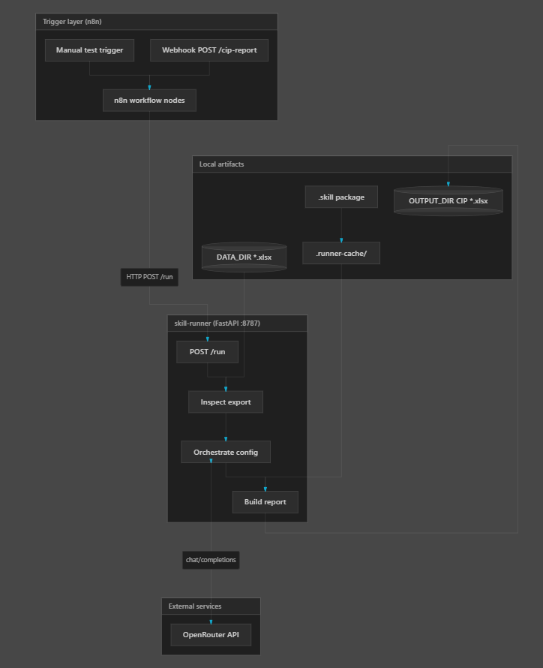
Figure 1. System architecture showing n8n triggers, the local FastAPI runner, packaged skill assets, input/output directories, and optional OpenRouter orchestration.
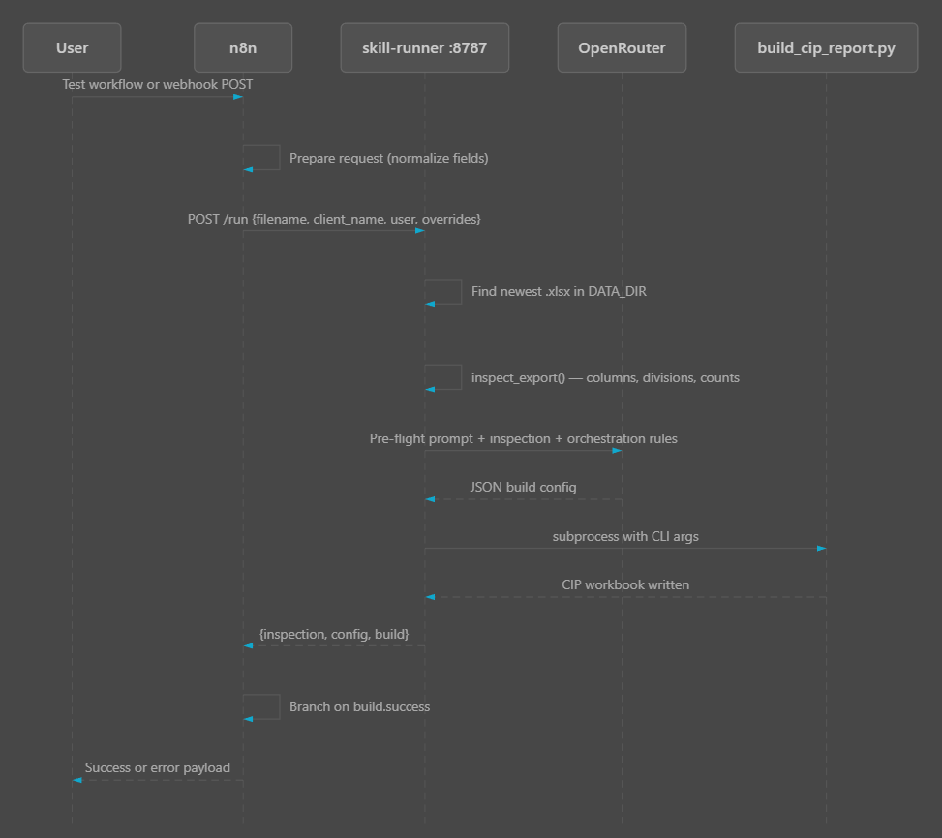
Figure 2. Request sequence from the user and n8n through inspection, configuration, report construction, and the final success or error payload.
Table 2. Major system modules and responsibilities
Module | File | Note
Config | runner/config.py | Loads .env, paths, host/port, keys
Inspect | runner/inspect.py | Finds export under DATA_DIR, reads columns/counts
Orchestrate | runner/orchestrate.py | OpenRouter (or offline defaults) -> build config.
Build | runner/build.py | Runs packaged skill script -> writes OUTPUT_DIR
Skill Loader | runner/skill_loader.py | Extracts .skill into SKILL_CACHE_DIR
API Server | runner/server.py | HTTP endpoints wrapping the pipeline
Workflow UI | n8n/cip-report-pipeline.json | Operator-facing trigger/flow

3.2 Data Flow and Component Boundaries
A manual trigger, schedule, or webhook enters through n8n. The workflow normalizes filename, client name, user, and optional overrides, then calls POST /run on the local runner. The runner resolves the workbook inside DATA_DIR, inspects its schema and values, combines policy defaults with the inspection and approved overrides, and invokes the packaged report builder. The builder writes a timestamped CIP workbook into OUTPUT_DIR. The API returns the resolved input, inspection metadata, final configuration, and build result so that the workflow can branch on success without embedding report logic in n8n.
This separation of concerns is deliberate. n8n provides scheduling and operator visibility; FastAPI exposes stable contracts; the inspection module establishes data quality; orchestration selects bounded parameters; the build wrapper performs safe subprocess execution; and the versioned skill package owns workbook formulas, tabs, calculations, and formatting. Excel files are the persistent input and output layer for the prototype, so a traditional database was not required.

3.3 Core Algorithms

3.3.1 Input Discovery and Filesystem Validation
The first algorithmic responsibility is to resolve the workbook that a run is allowed to process. The original implementation accepted a caller-supplied filename but did not sufficiently constrain the resulting path. Unit testing exposed that a value such as ../outside.xlsx could escape the configured data directory. This was both a data-integrity defect and a security weakness because the public API contract implied that all inputs came from DATA_DIR. The corrected algorithm resolves both the base directory and requested path, verifies that the candidate remains within the trusted directory, enforces the .xlsx suffix, and confirms that the candidate is a regular file.
The resulting behavior is deliberately fail-fast. A named file that is absent, outside the trusted boundary, not a file, or not an Excel workbook raises a specific error before inspection or report generation begins. When no filename is supplied, the discovery logic can select the newest valid workbook in the data directory. This default supports scheduled operation while retaining a predictable rule. The approach converts an implicit filesystem assumption into an explicit, testable contract.
This implementation illustrates a broader project lesson: validation is not a separate final step but part of the core algorithm. By constraining the file at the entry boundary, downstream modules can treat the resolved path as trusted. Regression tests now cover path traversal, nonexistent files, invalid extensions, and empty directories so the defect is unlikely to return during refactoring.

3.3.2 Workbook Inspection and Pre-flight Metadata
After input discovery, the inspection module reads the workbook and returns a compact ExportInspection structure. The structure records the file path, row count, column names, available divisions, and missing required columns. This stage separates data-quality discovery from report construction. The builder does not need to repeatedly infer the input shape, and the orchestrator receives a concise description rather than an entire financial workbook.
The inspection result is also a control point. Required-column validation stops the run before an LLM call or long-running build when the export cannot support the report. That design improves both efficiency and explainability. A missing-column error can name the absent fields directly, rather than appearing later as an ambiguous calculation or formatting failure. Division values discovered in the export are passed forward as the allowable domain for configuration.

3.3.3 Schema-Driven Orchestration
The principal orchestration algorithm is orchestrate_build_config. Its purpose is to convert inspection metadata, pipeline defaults, and optional user overrides into one validated JSON configuration for the CIP report skill. The configuration schema names each required field and its expected type or permitted values. Important fields include client_name, branches, divisions, completed and overview date ranges, minimum estimated revenue, subcontractor margin, invoice flags, cost-pace threshold, user, change note, and a short rationale
The orchestration sequence applies an explicit precedence rule. First, the system loads pipeline-level defaults from the versioned orchestration Markdown file. Second, it adds the packaged skill's pre-flight guidance. Third, it supplies the inspection metadata and user context. Finally, explicit run-time overrides take priority. This order prevents interactive suggestions embedded in a skill from silently overriding operational policy and ensures that a user-approved override remains the final decision.
Before any remote model request, the function checks inspection.missing_required_columns. If required data is absent, it raises a clear error and does not incur an API call. If the OpenRouter key is not configured, _default_config builds a complete configuration from known divisions and domain defaults. If an API key is present, the function sends a constrained system instruction and JSON user payload, requests a JSON object response, and uses a low temperature of 0.1. The low temperature reduces unnecessary variability but is not treated as a guarantee of determinism; validation and deterministic fallbacks provide the actual control.
LLM responses occasionally contain explanatory text surrounding the requested object. The _extract_json helper first attempts direct parsing. If direct parsing fails, it isolates an object-shaped substring and parses again. The output then passes through configuration validation and runtime-default application. This two-stage recovery handles a common integration irregularity without allowing arbitrary text to flow into the builder. A malformed or incomplete object still fails explicitly.

3.3.4 Deterministic Fallback and Build Execution
The fallback path is a significant result because it proves the pipeline is not operationally dependent on a model call. _default_config derives divisions from the inspected workbook, falls back to the Construction division when appropriate, and assigns versioned domain values for date windows, margin thresholds, invoice rules, and report notes. _apply_runtime_defaults then merges settings loaded for the current environment or reporting policy.
This fallback has two implications. First, routine runs can avoid token cost and model latency when known defaults are sufficient. Second, service interruptions or model-policy changes do not stop the core report pipeline. The model becomes an optional configuration assistant rather than an irreplaceable runtime. That result directly supports the original goal of reducing vendor dependence.
The run_pipeline function composes the individual algorithms into one asynchronous use case. It resolves the input file, inspects it, awaits orchestration, invokes the deterministic builder, and returns a structured record of the input, inspection, configuration, and build result. Each module retains a focused responsibility, which improves testability and makes failures easier to localize.
The build module converts the configuration into a safe argument list and runs the packaged report generator as a subprocess. Using an argument list rather than a shell-constructed string reduces quoting errors and command-injection risk. Standard output, standard error, return code, and output-file information are captured in the build result. A nonzero return code produces a controlled failure response with diagnostic details instead of an unexplained server exception.

3.4 Tools and Configuration
The implementation uses Python 3.11 or newer, FastAPI and Uvicorn for the local service, pandas and openpyxl for workbook inspection and acceptance checks, n8n for workflow control, Git and GitHub for versioning, and OpenRouter as an optional model gateway. Environment values define input/output directories, the host and port, default client and user, model settings, n8n credentials, the skill package, the cache directory, and an optional logo. Live secrets are excluded from version control; a placeholder .env.example documents required keys.
The repository stores the n8n workflow as JSON and the pipeline policy as orchestration Markdown. The report engine ships as a versioned .skill archive and extracts into a local cache on first use or when the package changes. Alternate entry points - n8n, the command-line interface, and individual API endpoints - use the same underlying modules, which supports debugging and repeatable verification without duplicating business logic.

3.5 Security and Ethical Design Controls
Primary risks include leakage of financial or operational data, mishandled credentials, unauthorized report execution, model-generated configuration errors, insufficient logging, and unsafe file access. The design addresses these risks through anonymized inputs, local-first data handling, path containment, extension and regular-file checks, schema validation, environment-based secrets, private repositories, safe subprocess argument lists, controlled error responses, and human review. These controls align with OWASP's emphasis on access control, secure design, cryptographic protection, and logging, while recognizing that the prototype lacks enterprise authentication and formal threat-model review (OWASP, 2025).

3.6 Evaluation Methodology
Testing was designed to determine whether the integrated system performs its primary workflow correctly, rejects unsafe or invalid requests, remains responsive at the API layer, produces a structurally valid CIP workbook, and provides sufficient diagnostic evidence for maintenance.
In scope: file discovery, export inspection, orchestration defaults and overrides, command construction, skill extraction, API health and data endpoints, invalid-path handling, generated workbook structure, and performance evidence.
Unit testing: execute unit test discovery against tests/ to verify internal behavior, negative cases, and regression boundaries in isolation.
Integration testing: call the running FastAPI endpoints for health, data inventory, and workbook inspection; verify the actual input is discovered and parsed.
System testing: exercise the integrated API and output artifacts, including rejection of a directory-traversal filename and workbook validation with the packaged pipeline output.
Acceptance testing: verify operator-visible criteria - service availability, accessible input inventory, a readable output workbook, required worksheets, and safe rejection behavior.
Performance review: use the measured July 28, 2026 benchmark set for latency, throughput, memory, and end-to-end batch runtime.
Table 3. System test environment and evidence baseline
Item | Configuration
Host | Windows; local services on 127.0.0.1
Application | FastAPI skill-runner v0.1.0; n8n trigger; packaged CIP skill
Input | Anonymized_Opportunity.xlsx; 6,989 rows
Output | CIP_Report_20260809_122617.xlsx; 3,925,982 bytes; audit manifest generated
Test framework | Python unittest; live HTTP checks; openpyxl acceptance harness
Test date | August 9-10, 2026 (America/Chicago)

Pass/fail decisions used explicit observable criteria. Functional evidence required successful module tests, real API responses, safe rejection behavior, readable workbook output, and required worksheets. Performance evidence used previously captured benchmark runs under the same local architecture. Limitations were documented when a test relied on mocks, a small sample, sequential clients, or observational usability evidence.

Chapter 4: Results and Evaluation

4.1 Implementation Outcome
This chapter consolidates the implementation, integration, and evaluation work completed throughout the project for the deterministic skill-runner prototype. The project began with a practical reporting problem: analysts could use large language model (LLM) chat sessions to accelerate report creation, but the resulting process was difficult to reproduce, audit, maintain, and transfer. The implemented system replaces that ad hoc interaction pattern with a controlled pipeline. A user or scheduled n8n workflow submits an input workbook and run parameters to a locally hosted FastAPI service. The service locates and inspects the workbook, generates or defaults a validated build configuration, executes the packaged Construction-in-Process (CIP) reporting skill, and writes the finished Excel workbook to a controlled output directory.
The completed prototype met the core technical objective established in the earlier project plan: it generated a standardized report from an export without requiring a live chat session during the build. The system also met the principal functional acceptance conditions used throughout Units 5 and 6. It accepted a named .xlsx input from DATA_DIR; rejected missing, malformed, or unsafe inputs; combined inspection metadata, orchestration rules, and optional user overrides; produced a machine-readable configuration; invoked the report builder as a subprocess; retained diagnostic output when the builder failed; and returned a structured response identifying the generated file. These results demonstrate a working proof of concept rather than a purely conceptual architecture.
The results also show that determinism was introduced at the correct boundary. The LLM, when configured, is used for a narrow pre-flight decision: selecting report parameters from an explicit schema and known metadata. It is not permitted to regenerate the calculation or workbook-building code on every run. The numerical transformations, workbook layout, file access rules, and subprocess execution remain in version-controlled Python and packaged skill assets. When no OpenRouter key is present, the pipeline continues through a deterministic default configuration. This separation means that the system can benefit from context-aware configuration while preserving a stable execution path for the business-critical report.

4.2 Integrated System Output
The completed integration follows a clear path: an n8n manual trigger, schedule, or webhook prepares a request; n8n sends POST /run to the FastAPI service; the service invokes run_pipeline; the pipeline inspects the workbook and obtains a configuration; the builder creates the CIP workbook; and the API returns a structured success or failure response. Excel files serve as the persistent data layer for this prototype. No traditional database is required.
The FastAPI layer exposes health, data, inspection, orchestration, build, and combined run endpoints. Separating the endpoints supported incremental verification during development, while /run provides the single operation required by automation. The endpoint converts known file, validation, and build problems into useful HTTP errors. This is more maintainable than embedding all logic in the route handler because the same pipeline functions remain callable from the command-line interface and unit tests.
The n8n workflow provides the user-facing operational layer. Its nodes normalize incoming fields, call the local runner with a ten-minute timeout, branch on build.success, and return either a successful payload or a controlled failure payload. The workflow canvas makes execution status visible to an analyst without requiring direct Python interaction. It also supports both manual testing and webhook-based automation using the same backend contract.
The integrated output contains four evidence groups: the resolved input path, inspection metadata, final configuration, and build result. In the successful run captured during integrated testing, the response identified the source workbook, returned the selected report parameters, recorded the resulting output path, and marked the build successful. This structure supports traceability because a generated workbook can be associated with the exact configuration used to create it.
The design also supports reproducibility at the artifact level. Skill packages are versioned and extracted into .runner-cache on demand. The n8n workflow definition is stored as JSON and can be synchronized through the project CLI. Repository tags identify meaningful releases, including the first runnable prototype, n8n integration, and the first stable unit-tested release. Together, configuration files, workflow definitions, packaged skill assets, and release tags identify the technical state needed to repeat a run.
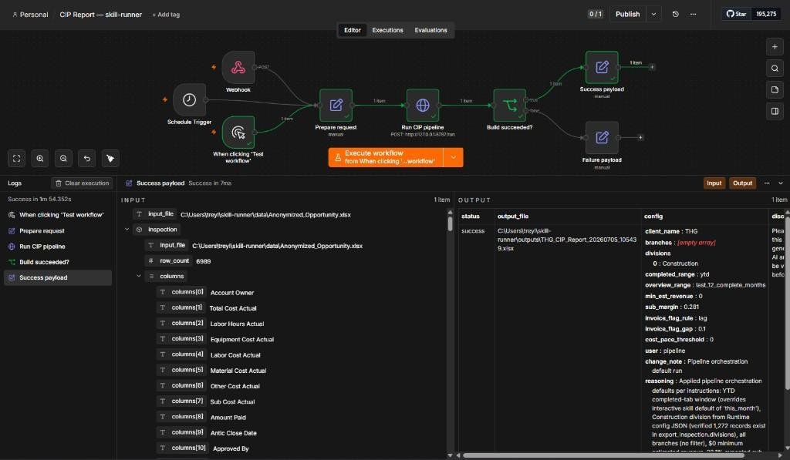
Figure 3. Successful n8n end-to-end workflow used to trigger and monitor the CIP report pipeline.

4.3 System and Acceptance Test Results
This report documents comprehensive testing and a post-deployment maintenance strategy for the skill-runner. Fresh validation on August 9, 2026 combined 29 unit tests, live integration, system and acceptance checks, audit-manifest verification, and updated performance evidence. The August 10 comparison then reproduced the same CIP through Claude Teams using the same source data and filters.
Overall result: PASS with documented limitations. All 29 automated unit tests passed; the live API was healthy; all 6,989 source rows were inspected with no missing required columns; the latest 3.93 MB output workbook opened with all nine expected worksheets; and the instrumented run produced a traceable audit manifest whose recorded output hash matched the workbook.
The earlier virtual-environment issue was resolved by recreating the project environment from requirements.txt under Python 3.12.13. The clean environment passed 29 tests and the end-to-end validation. Future maintenance should retain a setup smoke check and avoid distributing machine-bound virtual environments.
Table 4. Unit, integration, system, acceptance, and performance test summary
ID | Level | Procedure | Observed result | Status
UT-01 | Unit | Run full suite | 29/29 pass in 0.099 s | PASS
IT-01 | Integration | GET /health | status=ok | PASS
IT-02 | Integration | GET /data | 1 anonymized workbook discovered | PASS
IT-03 | Integration | POST /inspect | 6,989 rows; 0 required columns missing | PASS
ST-01 | System | Reject ../outside.xlsx | HTTP 404; trust boundary enforced | PASS
ST-02 | System | Open latest CIP workbook | 3.93 MB workbook opened; 9 sheets; audit hash verified | PASS
AT-01 | Acceptance | Required output worksheets | Dashboard, In Process, Completed, Complete Overview, Table, Version History present | PASS
PT-01 | Performance | API control plane | Health mean 11.74 ms; 126.45 req/s | PASS
PT-02 | Performance | Batch generation | 87.314 s for 6,989 rows (instrumented run) | PASS

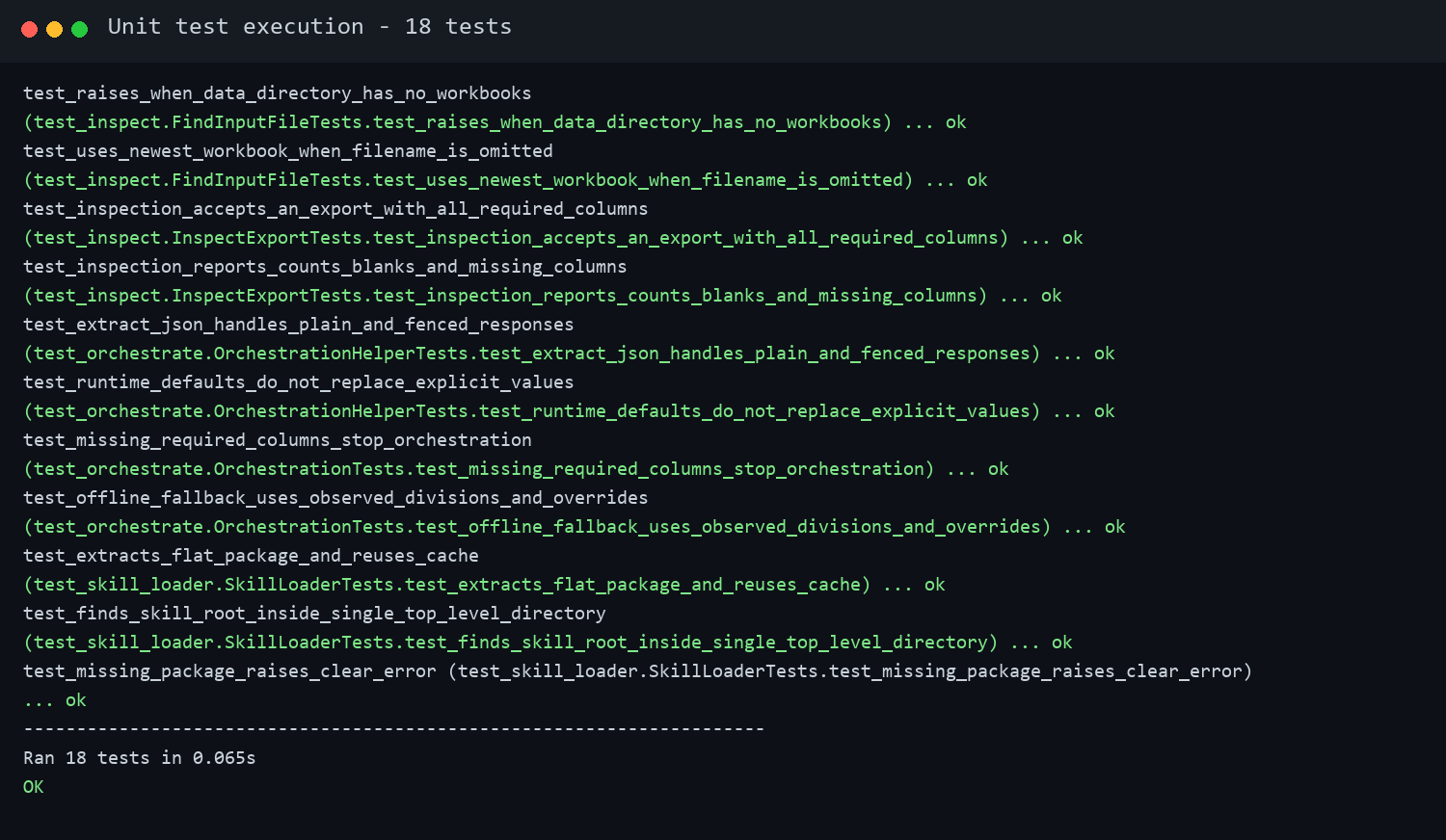
Figure 4. Historical automated test baseline showing 18 tests passed; the expanded current suite passes 29 tests.
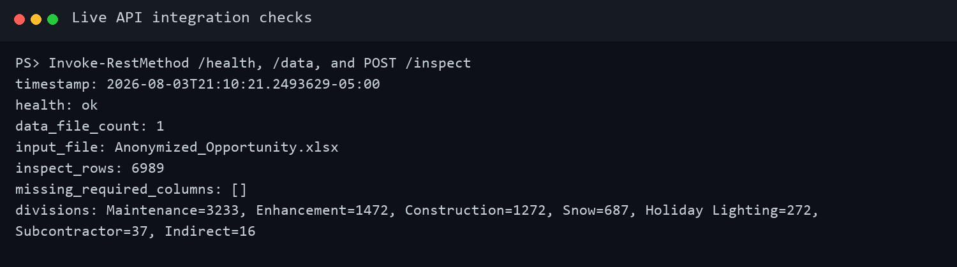
Figure 5. Live API integration evidence for health, input discovery, and 6,989-row workbook inspection.
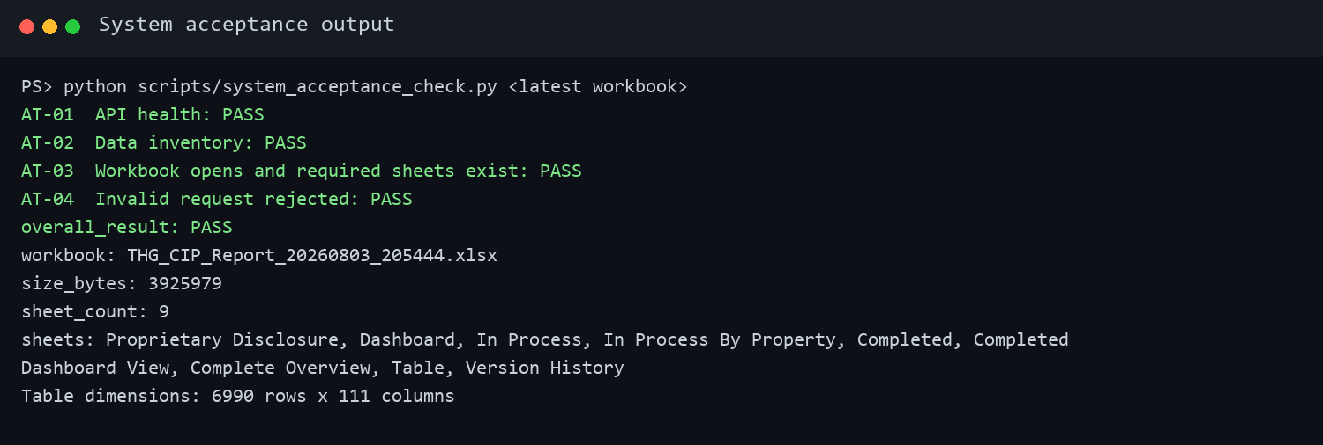
Figure 6. Acceptance evidence confirming API availability, invalid-request handling, and the workbook contract.

4.4 Performance and Resource Results
The evaluation combined correctness, latency, throughput, memory, end-to-end runtime, and interface observations. These measures were appropriate for a prototype whose main claim is reliable report automation rather than high-volume public web service operation. The evidence shows that the lightweight control plane is fast, the workbook operations dominate run time, resource use is moderate, and the functional test suite provides strong coverage of the known decision points.
The expanded automated suite passed all 29 tests in 0.099 seconds. Coverage includes input discovery, workbook inspection, missing-column rejection, configuration translation, empty-division rejection, runtime defaults, JSON extraction, subprocess success and failure, path-traversal prevention, packaged-skill discovery and cache reuse, neutral output naming, success and failure manifests, reconciliation tolerances, pipeline-manifest integration, and reproducibility hashing. Figure 4 preserves the earlier 18-test baseline screenshot as historical evidence; the current 29-test result is retained in outputs/unit-test-results.txt.
Control-plane GET endpoints performed at approximately 12 milliseconds. The health endpoint averaged 11.74 ms across 50 sequential requests, with a median of 14.875 ms and a 95th percentile of 16.292 ms. The data-listing endpoint averaged 11.93 ms across 30 requests, with a median of 15.056 ms and a 95th percentile of 16.047 ms. The health endpoint sustained 126.45 requests per second for 200 successful responses in a sequential-client test. These figures indicate that FastAPI routing and basic configuration access introduce negligible delay relative to spreadsheet work.
Workbook inspection averaged 3,297 ms, or approximately 3.3 seconds, across five performance-study runs. A subsequent instrumented end-to-end CIP run processed 6,989 rows in 87.314 seconds and generated a JSON audit manifest whose output hash matched an independent calculation. The earlier 114.352-second benchmark and 133.818-second release-candidate run remain useful historical observations, but none should be treated as a guaranteed service level.
Memory measurement showed 143.89 MB resident set size for the listening Uvicorn worker and 148.45 MB for the parent and worker combined. This footprint is acceptable for a Windows analyst workstation and is small compared with the memory typically available on current business systems. It also supports the selected local deployment approach because the runner does not require a dedicated high-capacity server for the pilot.
Qualitative evaluation rated interface usability and clarity as high. The Swagger /docs interface is self-documenting; the n8n canvas exposes the success/failure route and duration; the structured response includes a human-readable rationale; neutral CIP_Report timestamps prevent client-name leakage in filenames; and manifests improve auditability. These observations remain design evidence rather than a formal usability study with multiple participants.
The combined result is summarized as follows: correctness passed at 29/29 tests; control-plane latency was low; health throughput was more than sufficient for a local single-team service; memory was acceptable for the prototype; workbook inspection and end-to-end generation aligned with file-intensive batch processing; and the operator interfaces were understandable. The current validation also confirms manifest generation and output-hash integrity.
Table 5. Measured latency, throughput, memory, and batch runtime
Metric | Result | Method / context
GET /health latency | 11.74 ms mean; 16.292 ms p95 | 50 sequential requests
GET /data latency | 11.93 ms mean; 16.047 ms p95 | 30 sequential requests
POST /inspect latency | 3,297 ms mean | 5 workbook parses
GET /health throughput | 126.45 requests/second | 200/200 successful
Worker memory | 143.89 MB RSS | Listening worker on :8787
End-to-end CIP run | 87.314 seconds | 6,989-row instrumented n8n run; manifest and hash verified
Claude Teams reproduction | 5 min 59 s; 19 steps | Same source and filters; model-reported steps; one observed run
Skill-runner inference cost | $0.02 per observed run | DeepSeek V4 Flash through OpenRouter; no rate limit observed
Claude subscription context | $125/month | Claude Teams 5x plan used by the organization; pricing and plan limits may change
Comparative execution result | 75.7% less elapsed time | 271.686 s shorter; runner about 4.1x faster; review time excluded
Post-run comparative review | Approximately 1 minute | Separate from the measured 5:59 Claude execution runtime

4.4.1 Comparative Claude Execution Evidence
A screen-recorded comparison on August 10, 2026 reproduced the same CIP from the same source data and filters through Claude Teams. Claude reported 19 execution steps and completed the workbook in 5 minutes 59 seconds. Approximately one additional minute was used to compare the result; that review time is reported separately and is not included in either system's execution runtime. The instrumented skill-runner run completed in 87.314 seconds, making it approximately 4.1 times faster and reducing elapsed execution time by 75.7 percent for the observed pair.
The Claude run used the organization's Claude Teams 5x plan at $125 per month. The skill-runner used DeepSeek V4 Flash through OpenRouter and incurred approximately $0.02 for the observed run, with no rate limit encountered. The report is produced weekly for approximately 20 clients, so a reusable runner avoids requiring every routine execution to occur within a subscription chat product. This is an observational single-run comparison: it supports feasibility and dependency-reduction claims, but it does not establish guaranteed future pricing, provider availability, rate limits, or service levels.

4.5 Defects, Corrections, and Remaining Issues
Table 6. Resolved defects, environment issues, and coverage limitations
ID | Type | Finding | Resolution / disposition | State
ISS-01 | Resolved product defect | A named input such as ../outside.xlsx could previously escape DATA_DIR. | Resolved-path containment, .xlsx, and regular-file checks added; regression coverage passes. | Closed
ISS-02 | Environment issue | The repository virtual environment referenced a removed Python runtime. | Recreated the environment from requirements.txt with Python 3.12.13; 29 tests and end-to-end validation passed. | Closed
ISS-03 | Test-harness issue | Initial acceptance specification expected generic worksheet names not used by the CIP template. | Updated required-sheet criteria to the actual workbook contract; rerun passed 4/4. | Closed
LIM-01 | Coverage limitation | OpenRouter and subprocess behavior are mocked in unit tests; this cycle did not inject live network failures. | Add a sandbox/staging contract test with recorded responses and controlled timeout/rate-limit scenarios. | Planned
LIM-02 | Production limitation | No full security review, sustained load test, or role-based access validation has been completed. | Complete security and load gates before production deployment. | Planned

The first acceptance-harness run failed because the test expected worksheet names that were not part of the actual CIP template. The workbook opened normally. After the required-sheet criteria were corrected to match the approved workbook contract, the harness passed. This was classified as a test-specification correction rather than a product failure. By contrast, the earlier path-traversal behavior was a product defect and was closed only after containment logic and regression coverage were added.
Comprehensive testing improves reliability by checking the system at several boundaries rather than relying on a single successful demonstration. Unit tests isolate decision logic and make regressions fast to locate. Integration tests verify that modules exchange real data correctly. System and acceptance tests confirm that the deployed behavior matches an operator's expectations, including safe failure behavior. Performance evidence shows whether correct results arrive within a practical operating window.
The combined approach also improves quality management: failures can be classified as code defects, environment problems, test-specification errors, or accepted limitations. That classification prevents false confidence, makes maintenance work easier to prioritize, and creates a repeatable baseline for future releases.

Chapter 5: Discussion

5.1 Interpretation of Results
The results support the central architectural position described in the project's literature review: LLM capabilities are most dependable when placed inside a structured workflow with deterministic modules, validation, and traceability. Aluso and Enyejo (2023) describe the promise of LLM-augmented ETL while warning about hallucination, explainability, governance, and cost. The skill-runner responds by limiting the model to schema-bound configuration. Spreadsheet inspection, financial calculations, workbook generation, path handling, and failure reporting remain deterministic. The 29 passing tests do not prove that every financial output is correct, but they demonstrate that the architecture can enforce stable contracts around the probabilistic component.
The prototype also aligns with Sai and K.'s (2025) account of enterprise intelligence systems that combine AI services with rule-based modules. Their emphasis on consistency, traceability, modularity, and lifecycle management appears directly in the project's separation of inspection, orchestration, build, API, and workflow layers. The structured /run output retains inspection, configuration, and build information rather than returning only a finished filename. Versioned releases and packaged skill assets add lifecycle context. The successful integration therefore contributes a concrete small-scale example of how an AI-assisted decision can be isolated inside a conventional software pipeline.
Wang et al. (2026) report that reusable domain skills can improve stability, token efficiency, interpretability, and reproducibility compared with ad hoc prompts. The skill-runner offers parallel evidence in a business-intelligence setting. In the August 10 observational comparison, Claude Teams reproduced the same-input, same-filter CIP in 19 model-reported steps and 359 seconds. The runner completed the comparable instrumented execution in 87.314 seconds, a 75.7 percent reduction, and used approximately $0.02 of OpenRouter inference. This single comparison does not prove universal cost or performance savings, but it supplies direct evidence for the proposed mechanism: stored code and a narrow model role reduce repeated interactive execution and lessen dependence on one subscription interface.
The results are also relevant to Vangala et al.'s (2026) reproducibility concerns about AI-generated code. Their findings suggest that generated projects frequently fail because of dependency and core-code problems. The skill-runner does not assume that generated code is reliable simply because it ran once. Instead, code is generated or developed, stored, tested, tagged, and then executed as software. The 29-test suite, deterministic fallback, environment example, audit manifests, and release tags are practical responses to reproducibility risk. The path-traversal defect found by testing is particularly instructive: a plausible implementation still contained a serious boundary error until a negative test exposed it. The result reinforces the literature's argument for conventional software assurance around AI-assisted development.
The performance results also clarify the system's intended operating model. Approximately 12-millisecond control-plane responses show that the service and routing layers are not bottlenecks. Workbook inspection averaged 3.3 seconds, while observed end-to-end runs ranged from 87.314 to 133.818 seconds depending on the validation run. Workbook parsing, calculations, formatting, and output writing dominate. This is acceptable for a scheduled or analyst-initiated batch process and compares favorably with the observed 359-second Claude Teams reproduction, but none of these runs establishes a guaranteed service level.

5.2 Project Management and Deployment Implications
From a project-management perspective, the implementation also reflects Oguz's (2025) emphasis on scope, risk, monitoring, and control. The project was deliberately limited the pilot to one representative CIP reporting use case, a local deployment, basic performance testing, and a minimal operator interface. That boundary made it possible to deliver a working integration within the project period. The measured results provide a baseline for monitoring; versioned settings reduce uncontrolled change; and explicit exclusions prevent the prototype from being misrepresented as production hardened.
Three deployment patterns were considered: cloud hosting, on-premises hosting, and containers. A cloud service or virtual machine would improve centralized access and scheduling but would require stronger identity controls, network design, secrets management, and review of how sensitive construction financial data leave the local environment. A Docker deployment would improve portability and dependency consistency but adds container orchestration, volume, and operational support decisions that were not necessary to prove the use case. The selected prototype approach is an on-premises Windows analyst workstation with n8n and the runner on the same host.
The choice is consistent with the measured workload and current risk posture. The API binds by default to 127.0.0.1:8787, so it is not exposed broadly. Inputs remain in DATA_DIR, outputs remain in OUTPUT_DIR, and the Uvicorn worker uses roughly 144 MB. The report is generated as a batch operation rather than an interactive, high-concurrency service. Local deployment therefore minimizes infrastructure overhead and reduces unnecessary data movement while still allowing automation through n8n.
This configuration model improves reliability by making environment differences visible. A developer does not need to edit Python to move input or output directories, change ports, select a model, or associate a workflow. It also supports eventual migration: the same code and versioned configuration contract can be adapted to an internal server or container by supplying new environment values and mounted storage. Nevertheless, .env files alone are not a production secrets-management solution. A future shared deployment should use an operating-system credential store, vault, or platform-managed secrets.

5.3 Limitations
The first limitation is evaluation scale. The end-to-end result is based on a representative 6,989-row export and a small number of timed runs. The inspection average uses five runs; endpoint measurements use tens or hundreds of sequential requests; and there is no sustained concurrent-load test. These measurements establish a useful baseline but do not characterize performance across all clients, workbook sizes, storage devices, or simultaneous users.
Second, the 29 tests emphasize module behavior and integration boundaries rather than exhaustive validation of financial calculations. Mocks are valuable because they make tests fast and local, but they can hide mismatches between the test double and a real OpenRouter response, n8n version, Excel export, or packaged skill. The project needs approved golden-workbook comparisons, cell-level reconciliation, and end-to-end regression cases that verify both values and formatting.
Third, the usability rating is observational rather than the result of a formal user study. Swagger and n8n are understandable to technical users, but the target population includes analysts and client operations staff with varying experience. The project did not measure task completion, error rate, satisfaction, learnability, or accessibility with multiple participants. A high qualitative rating should therefore be interpreted as design evidence, not proof of broad user acceptance.
Fourth, the selected local deployment reduces network exposure but creates workstation dependence. If the host is powered off, misconfigured, or unavailable, scheduled runs stop. Local folders can also complicate backup, retention, multi-user access, and separation of duties. The prototype lacks enterprise authentication, authorization, centralized logging, encrypted secret storage, service supervision, disaster recovery, and formal security review. These exclusions were appropriate to the project's scope but prevent an immediate production rollout.
Fifth, the system remains partially vendor dependent when context-aware orchestration uses OpenRouter or another model provider. The deterministic fallback preserves continuity, but it may not make the same context-sensitive selections as the model. The project did not quantify how often model-selected configurations differ from approved defaults or whether those differences improve report quality. The claim is therefore reduced dependency, not complete vendor independence.
Finally, the evidence package now includes structured success/failure manifests, input and output hashes, configuration, timing, package identity, and Git state for instrumented runs. Historical artifacts created before manifest support still lack complete provenance, and a final analyst-approved golden-workbook reconciliation remains outstanding. Continued runs should retain manifests and visual/formula review evidence.

5.4 Maintenance Strategy
The maintenance plan translates the final testing baseline into post-deployment controls. Following the four-part maintenance framework described by Thales (n.d.), each change is classified by its reason and paired with a regression and release obligation.
Table 7. Maintenance categories applied to the skill-runner
Type | Purpose | Application to skill-runner
Corrective | Repair defects after deployment. | Fix parsing errors, unsafe file selection, failed builds, incorrect formulas, or API exceptions. Add a regression test for every confirmed defect.
Adaptive | Keep the system compatible with changing conditions. | Update for new export columns, Python/FastAPI versions, n8n APIs, OpenRouter models, Windows environments, and workbook-template revisions.
Perfective | Improve capability, usability, or performance. | Reduce workbook build time, improve operator messages, add dashboards, strengthen reconciliation, and streamline configuration.
Preventive | Reduce the probability or impact of future failure. | Patch dependencies, rotate secrets, test backups/restores, pin compatible versions, validate templates, monitor disk use, and rehearse rollback.

Table 8. Monitoring and maintenance schedule
Cadence | Owner | Activity | Escalation trigger
Every run | Runner / n8n | Capture timestamp, input filename/hash, skill version, configuration, exit code, duration, output path, and validation result. | Failed run, missing output, or reconciliation warning
Daily | Operations | Review failed executions, disk space, orphaned outputs, and credential errors. | Any failure or <20% free disk
Weekly | Maintainer | Run unit and acceptance suites; sample one generated workbook; triage open defects and requests. | Any regression or repeated warning
Monthly | Maintainer + analyst | Review latency, build duration, error rate, dependency advisories, data/schema drift, and user feedback. | >20% runtime regression or schema change
Quarterly | Technical owner | Patch supported dependencies, test restore/rollback, review permissions and secrets, and validate n8n/skill compatibility. | Unsupported dependency or failed recovery drill
Annually / major release | Project owner | Reassess architecture, capacity, risk register, retention policy, and production-readiness controls. | Material business/process change

5.5 Change, Release, and Recovery Control
Each change should begin with an issue describing purpose, scope, owner, risk, and acceptance criteria. Work occurs on a short-lived branch, with code, tests, documentation, configuration examples, and the packaged skill updated together. Unit, integration, acceptance, and relevant performance checks run in a clean environment before review. Approved releases receive semantic tags and release notes with migration and rollback instructions, move first to staging, and retain the prior known-good release.
Release requires no known critical defect, passing unit and acceptance suites, reconciliation of a representative workbook, performance within 20 percent of baseline, successful secrets and configuration checks, and approved migration and rollback instructions. A data-integrity concern, security exposure, repeated build failure, missing required output, or impractical performance regression triggers rollback. Recovery uses the previous Git tag, skill package, workflow, locked dependencies, and configuration backup, followed by regeneration and root-cause review.

Table 9. Priority maintenance risks and response controls
ID | Risk / rating | Preventive control and contingency
R-01 | Security vulnerability or leaked secret (L=M, I=H) | Keep secrets out of Git; scan dependencies and commits; least privilege; patch cadence. Contingency: Rotate credentials, isolate the runner, review logs, redeploy a clean release.
R-02 | Input schema drift (L=H, I=H) | Validate required columns and types; maintain sample fixtures; alert on new/missing fields. Contingency: Stop the run safely, preserve input, map the new schema, release an adaptive update.
R-03 | Incorrect workbook formulas or data (L=M, I=H) | Automated reconciliation, required-sheet checks, golden-file comparisons, human review. Contingency: Quarantine output, restore prior skill version, regenerate, notify affected users.
R-04 | Dependency / runtime incompatibility (L=M, I=M) | Lock versions; clean-environment CI; quarterly upgrades; supported runtime matrix. Contingency: Rollback dependency or release; rebuild the virtual environment from lock data.
R-05 | n8n or OpenRouter outage / rate limit (L=M, I=M) | Timeouts, retries with backoff, offline deterministic defaults, health monitoring. Contingency: Queue the job, use documented fallback configuration, rerun after recovery.

Chapter 6: Conclusion and Future Work

6.1 Conclusion
The project produced a working deterministic skill-runner that converts an Excel export into a standardized CIP workbook through a controlled, locally hosted pipeline. The implementation integrates n8n, FastAPI, workbook inspection, schema-driven configuration, an optional OpenRouter decision step, deterministic defaults, a packaged report skill, and structured output handling. This is the project's most important finding: useful LLM assistance does not require the entire reporting process to remain inside an interactive chat. A probabilistic component can be narrowed to a replaceable pre-flight decision while the business-critical work remains in tested, version-controlled software.
Measured results support the prototype's feasibility. All 29 automated tests passed, control-plane operations completed in roughly 12 ms, workbook inspection averaged about 3.3 seconds, and an instrumented 6,989-row report completed in 87.314 seconds with a verified manifest and hash. In the same-source, same-filter comparison, Claude Teams completed in 359 seconds over 19 reported steps; the runner reduced elapsed execution time by 75.7 percent and incurred about $0.02 of OpenRouter cost. These figures indicate that the local control plane is lightweight and that deterministic execution is practical for weekly reporting across approximately 20 clients.
The implications extend beyond this single workbook. The project demonstrates a reusable pattern for organizations that want AI flexibility without surrendering reproducibility: inspect inputs deterministically, constrain any model output to an explicit schema, validate before execution, retain a deterministic fallback, package domain logic, expose a stable API, and record the resulting configuration and artifact. This pattern responds directly to concerns in the literature about hallucination, explainability, vendor dependence, and the reproducibility of AI-generated code.

6.2 Contributions
The project's first contribution is architectural. It shows how a domain skill can function as a versioned software asset rather than a disposable prompt. The second contribution is operational: n8n provides approachable scheduling and workflow visibility while FastAPI and Python provide a testable backend. The third contribution is assurance-oriented. Negative, boundary, and regression tests identified and corrected a real path-traversal weakness, demonstrating that ordinary software-testing practices remain essential in AI-assisted systems.
The project also contributes a measured baseline for a small business-intelligence automation. It documents correctness, control-plane latency, workbook-processing time, memory, throughput, traceability, and usability evidence. It also adds an observed same-input comparison between Claude Teams and the skill-runner, including execution steps, elapsed time, subscription context, and per-run inference cost. The results are not a production benchmark, but they provide an honest starting point for future comparison and capacity planning.

6.3 Lessons Learned
Several lessons emerged. First, explicit precedence rules are necessary when configuration can come from a skill, a pipeline policy, an LLM, and a user override. Without a documented order, the same input can produce surprising behavior. Second, low model temperature and JSON response formatting help but do not eliminate the need for parsing, schema validation, and fallback behavior. Third, fast unit tests provide disproportionate value: they found unsafe filesystem behavior and make refactoring practical without waiting for a two-minute report build.
Integration created challenges at every boundary. Excel exports may omit required columns or contain blank categories. LLM responses may contain extra text. Subprocesses may fail after producing useful diagnostics. Local paths and secrets differ among workstations. n8n, the API, and the builder must agree on field names and status semantics. The implemented solution addresses these issues through staged validation, structured objects, safe argument construction, environment-based configuration, and explicit success/failure payloads.
The project also clarified the difference between prototype success and production readiness. A successful local run proves the concept, not enterprise availability, security, governance, or user adoption. Recognizing that boundary is a positive result because it prevents premature deployment and identifies the next work precisely.

6.4 Future Work
The first recommendation is to create a gold-standard validation set. Several anonymized exports of different sizes and edge conditions should be paired with analyst-approved CIP workbooks. Automated tests should compare key totals, row counts, category assignments, formulas, date windows, and selected formatting elements. The test should distinguish material data differences from harmless metadata such as creation timestamps. This would convert reproducibility from a structural claim into an output-level measurement.
Third, the project should implement CI immediately because the test suite is already fast. A GitHub Actions workflow can create a supported Python environment, install dependencies, run all tests, scan dependencies, and validate that .env secrets are absent. Pull requests should require the checks to pass. Release jobs can package the skill, publish checksums, and attach deployment notes. A later deployment workflow could promote only tagged versions to a controlled staging host.
Fourth, observability should become a first-class module. Each run should receive a unique identifier and produce structured JSON logs. Metrics should include inspection duration, orchestration duration, build duration, total duration, row count, memory, output size, selected configuration, model/fallback path, and failure category. A lightweight dashboard could then show success rate, runtime trends, common validation errors, and volume by client without exposing sensitive workbook data.
Fifth, production security work should follow a threat model. Priorities include authenticated API access, authorization by client or data directory, rate limits, input-size limits, dependency scanning, restricted service accounts, secret rotation, encrypted transport when the service leaves localhost, output retention rules, and immutable audit logs. The path-boundary regression tests should remain and be extended to symbolic links, unusual Windows paths, and malicious filenames. Formula-injection and unsafe workbook-content tests should also be added.
Finally, future research should examine maintainability of the skill abstraction itself. Measures could include time to add a second report type, number of shared modules reused, configuration changes required, defect rate, and time for another developer to complete a documented modification. A successful second skill would demonstrate that the architecture is a platform rather than a one-report automation. Candidate use cases include weekly operations, backlog, labor, and client-specific exception reports.
The immediate next improvement is output-level regression testing against analyst-approved golden workbooks. That step will strengthen the claim of reproducibility beyond module and structural behavior. The second priority is to retain manifests on every run and centralize their logs and operational metrics. The third is CI enforcement on every pull request, followed by release packaging and checksums. The fourth is a small user evaluation with analysts completing real tasks through n8n or a simplified interface. Future comparative runs should repeat both Claude and runner paths to report medians and ranges rather than relying on a single pair.
After those controls are established, the system can move from a single workstation to a supervised internal host or containerized staging environment. Authentication, authorization, secrets management, backup, retention, and monitoring should be prerequisites for shared use. Finally, implementing a second reporting skill will test whether the architecture generalizes and will provide a stronger measure of maintainability.
Overall, the project achieved its purpose: it transformed real-world LLM experimentation into a documented, testable, and evaluated system. The skill-runner reduces dependence on fragile chat sessions, preserves a path for context-aware AI assistance, and establishes a practical foundation for repeatable report automation. Its most durable lesson is that reliability comes not from asking an LLM to be deterministic, but from designing the surrounding system so that uncertainty is bounded, validated, observable, and replaceable.

REFERENCES
Aluso, L., & Enyejo, J. O. (2023). Integrating ETL workflows with LLM-augmented data mapping for automated business intelligence systems. International Journal of Scientific Research and Modern Technology, 2(11), 76. https://doi.org/10.38124/ijsrmt.v2i11.1078
Anthropic. (2026). What are skills? Claude Help Center. https://support.claude.com/en/articles/12512176-what-are-skills
BrowserStack. (2026). What is system testing? https://www.browserstack.com/guide/what-is-system-testing
GitHub. (2025). Continuous integration. GitHub Docs. https://docs.github.com/en/actions/get-started/continuous-integration
Hrupa, A. (2024, March 19). What is system testing in software testing. TestFort. https://testfort.com/blog/what-is-system-testing-in-software-testing
Oguz, A. (2025). Project management (2nd ed.). MSL Academic Endeavors. https://pressbooks.ulib.csuohio.edu/projectmanagement2ndedition/
OWASP. (2025). OWASP Top 10: 2025. https://owasp.org/Top10/2025/
Pandhare, H. (2025). Developing scalable quality assurance pipelines for AI systems: Leveraging LLMs in enterprise applications. World Journal of Advanced Research and Reviews, 26(1), 1871-1894. https://doi.org/10.30574/wjarr.2025.26.1.1268
Red Hat. (2024). What is DevOps? https://www.redhat.com/en/topics/devops/what-is-devops
Sai, A., & K., V. (2025). LLM-powered enterprise intelligence. International Journal of Scientific Research in Engineering and Management. https://ijsrem.com/download/llm-powered-enterprise-intelligence
Summers, B. L. (2012). Effective methods for software and systems integration. CRC Press.
Thales. (n.d.). Four types of software maintenance and what is software maintenance? https://cpl.thalesgroup.com/software-monetization/four-types-of-software-maintenance
Vangala, B. P., Adibifar, A., Gehani, A., & Malik, T. (2026). AI-generated code is not reproducible (yet): An empirical study of dependency gaps in LLM-based coding agents. arXiv. https://arxiv.org/html/2512.22387v2
Wang, Y., Zhang, Y., Tan, Y., & Zhang, Y. (2026). ChromSkills enables interpretable and reproducible agentic chromatin data analysis. bioRxiv. https://www.biorxiv.org/content/10.64898/2026.02.04.703888v1
Wu, J., & Bosa, D. (2026, June 16). Anthropic's Fable shutdown is a big moment for open-source AI.CNBC. https://www.cnbc.com/2026/06/16/anthropics-fable-shutdown-is-a-big-moment-for-open-source-ai.html

APPENDIX A: EVIDENCE INVENTORY
The following project artifacts support the reported testing and evaluation. Repository paths are retained from the testing evidence inventory so another maintainer can reproduce the checks or locate the generated workbook.
Table 10. Testing and evaluation evidence inventory
Artifact | Repository path | Purpose / result
Fresh unit log | outputs/unit-test-results.txt | 29 tests; pass
Live API results | outputs/system-testing-api.json | Health, data, and inspection
Acceptance results | outputs/system-testing-acceptance.json | 4/4 checks; pass
Performance metrics | outputs/performance-eval.json | Latency, throughput, memory, E2E
Acceptance code | scripts/system_acceptance_check.py | Reusable verification harness
Generated workbook | outputs/CIP_Report_20260809_122617.xlsx | 3.93 MB; 9 worksheets; audit manifest
Validation synthesis | docs/VALIDATION-REPORT.md | 29 tests; 87.314 s run; manifest/hash verification; evidence caveats
Claude comparison recording | docs/Claude reproduction useing same dataset and skill 2026-08-10 203930.mp4 | Same source/filters; 19 steps; 5:59 execution; ~1 min review

APPENDIX B: RELEASE CHECKLIST
Before promotion beyond the local pilot, the following controls should be confirmed:
- A clean supported Python environment can be created from locked dependency data.
- All unit, integration, system, acceptance, and relevant performance regression tests pass.
- An anonymized representative workbook reconciles to analyst-approved totals, formulas, worksheets, and filters.
- The API is authenticated and authorized for the intended deployment boundary; secrets are stored outside source control.
- Structured run logs record release, skill checksum, input/output hashes, configuration, duration, status, and sanitized errors.
- Backups, retention, restore, and rollback procedures have been tested with the prior known-good release.
- Release notes document changes, migration steps, known limitations, and rollback instructions.

